C# Scrapper

While running the project, first of all program.cs file is run in which main function calls.

Inside main function, initialize mapper and then enable visual styles for application . then after set compatible text rendering false for the application

Then application run the mainform() method.

Inside mainForm:-

First initialiseComponent :-All labels, buttons ,textbox , listboxes and checkboxes functionalities and declaration and size and point is declared in it.

Then call the loaddefault email, in this to and cc email Addresses get from appsettings and add in listbox.

Then log into file for endicia “Scrapper start”.

After running the project

Below webScrapper app runs and seen like below:-

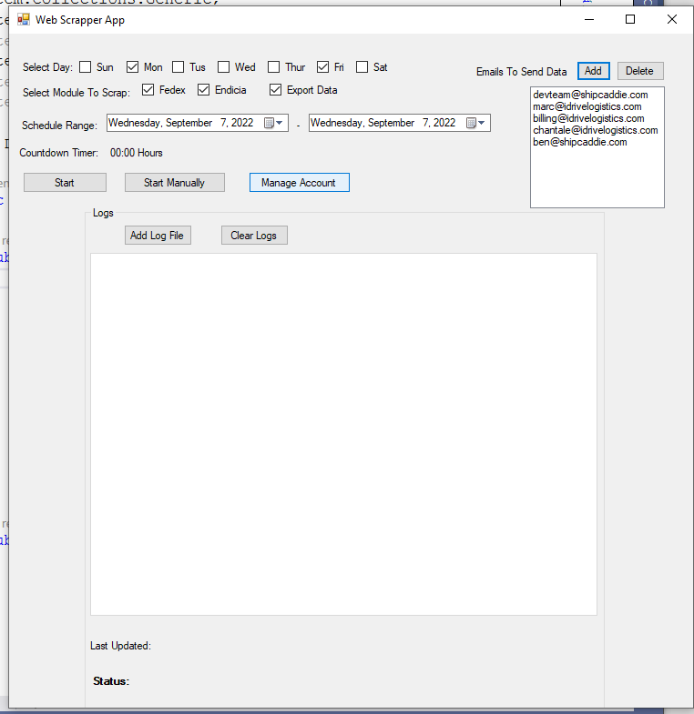

While click add log file dialog box for select file appears.

Select the file then checking for existing tab and check for network share and then add new tab for the file in which it is displayed in groupbox.then after click on start manually button.

Popup open name “manually scrap from”, in this select start date and end data

Then scrapping start by passing startdate end date and Boolean value in ScrapperInit method.

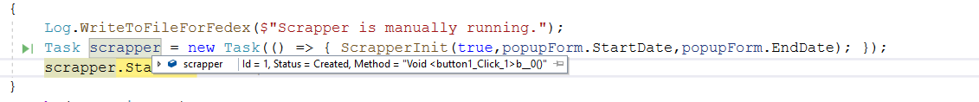

In this Method togglesatrtbutton and togglemanuallybutton is disabled.

Then carrier change method calls in which status is updated.

Then check if checkbox for fedex selected or for endicia selected or for export selected.

**If fedex is selected then,**

Then scrapper for fedex starts by passing start date , end date and boolen value for hasmanually property.

In this firstly get all active login users from FedexLoginAccounts table

then for each user scrap fedex data by calling ScrapFedexDataForUser Method

Then scrapping fedex data for first active user.

Then WebScrapperFedexInit.InitFedx method call by sending parameters.

In This Method initialize the fedexBrowser

Then initialize login helper in which get index of page login

Then login by username and password of active user.

Then log successful login

Then check billing and invoice page for user.

Then check multiple accounts exists and get list of accounts.then for each account

Extract billing and invoice details:- in this start from first page.

Get all inactive accounts by username.

Fedex tab enum are:-AllOpen ,PastDue ,PaidClose and InDispute.

Then extract invoice for fedex by tabname:-In this, data is inserted in FedexBillingAndInvoices table and log data is saved

Then for each account of user logged total rows total skipped rows and total disable rows.

Then close the fedex browser.

**Then check If endicia checkbox is checked.**

Then start scrapping for endicia in which

if hasmanually start date and end date has value then use these dates as start date and end date.

otherwise in case for Monday ,enddate date is current -1 day.

And for rest days end date is current date.

And start date is date of last Sunday.

Then log date range.

**For deleting old data logs for enterprise:-**

In start date is less then end date

Delete endicia old log from EndiciaScapperLogs table

And add 1 day in start date until start date equals to end date.

**For deleting old data logs for single account:-**

Delete endicia old log from EndiciaScapperLogs table

**Then Check export Checkbox is selected:-**

Get all emails from listbox and export data and send email in it

Then

if current day is Monday

then start date is Sunday and end date is end day count +1

else then start date is current day and end date is end day count +1

enable start and manually button.

On clicking start button it automatically scrap the data by checking day ranges from select day checkboxes.

And same scrapperInit method calls here.

On clicking Manage accounts:- Popup opens containing all Endicia Accounts , Fedex Main Account ,Fedex Sub-Account in separate tabs

User can add delete and cancel buttons for manage accounts.

**Endicia account tab**

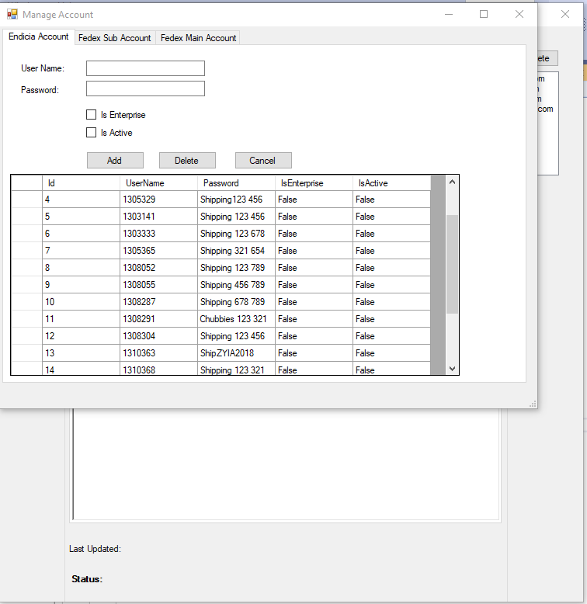

**Fedex Sub Account tab**

**Fedex main Account Tab**

